Practical 1
Objective: Configure routers to use the Routing Information Protocol (RIPv1) for dynamic routing. Enable RIP on the interfaces connected to different networks and verify that routes are being learned and propagated. Test the connectivity between hosts in different networks. (Using Packet Tracer)

Theory:
Routing Information Protocol (RIP): RIP is a distance vector dynamic routing protocol used to exchange routing information between routers. It uses the Bellman-Ford algorithm for route calculation.
RIP selects the best route based on Hop Counts, which represents the number of routers a packet must pass through to reach the destination.
- The route with the least hop count is selected as the best route.
- Maximum hop count allowed in RIP is 15.
- Hop count 16 means the destination is unreachable.
RIP Version 1 (RIPv1): RIP Version 1 (RIPv1) is the older version of RIP and is a classful routing protocol. In RIPv1, each router advertises its directly connected networks to neighbouring routers. These updates are exchanged at regular intervals, enabling routers to dynamically learn routes and update their routing tables automatically.
RIPv1 sends routing updates using broadcast communication, meaning the updates are delivered to all devices within the local network. Routing updates are transmitted every 30 seconds, ensuring that routers continuously refresh and maintain valid routes.
Important characteristics of RIPv1 include:
- RIPv1 is a distance vector protocol and uses hop count as its routing metric.
- It is a classful protocol, meaning it does not send subnet mask information in routing updates.
- It supports only classful addressing (Class A, Class B, Class C).
- It does not support VLSM (Variable Length Subnet Masking) due to the absence of subnet mask advertisement.
- It does not work efficiently in discontinuous networks because of automatic summarization.
- Routing updates are sent every 30 seconds and contain the complete routing table.
- It has a maximum hop limit of 15, which makes it suitable only for small networks.
- RIPv1 uses techniques such as split horizon and hold-down timers to reduce routing loops.
Thus, RIPv1 provides automatic route learning and dynamic routing, but due to its limitations such as classful behaviour and slow convergence, it is mainly used for small and simple networks.

Procedure:
Step 1: Create the Network Topology
- Open Cisco Packet Tracer.
- Add 3 routers.
- Add PCs (3 PC in each network).
- Connect:
  - PC to Router using Copper Straight-Through.
  - Router to Router using Serial DCE cable (or crossover if using Fast Ethernet).
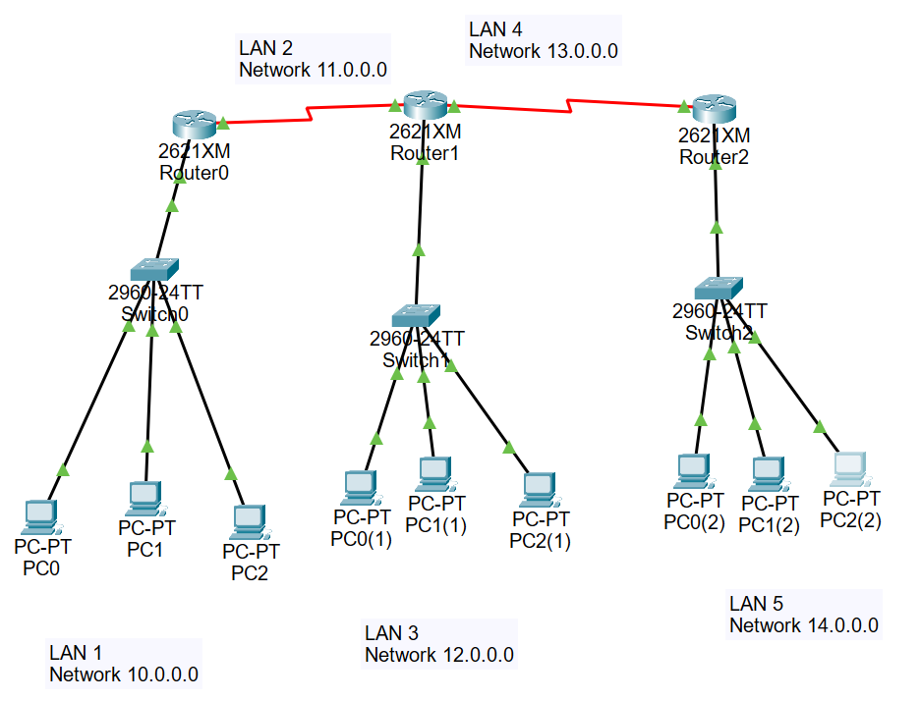
Step 2: Assign IP Address to PCs:
For each PC:
1. Go to PC → Desktop → IP Configuration 2. Assign:
IP Address
Subnet Mask
Default Gateway
- PC0: 10.0.0.2 / 255.0.0.0
- Gateway: 10.0.0.1
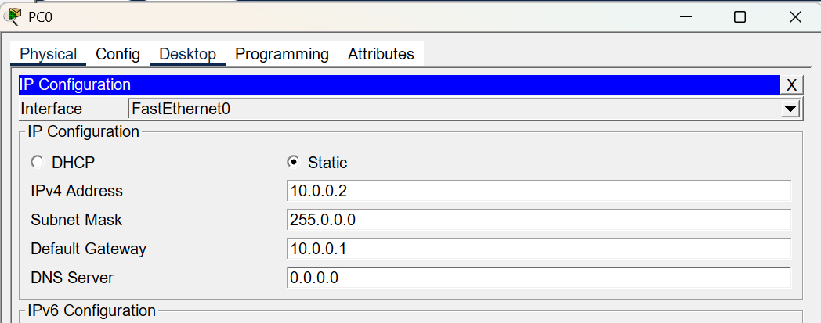
Step 3: Configure the Routers:
for each Router set up:
Router>enable
Router#
Router# configure terminal
Enter configuration commands, one per line. End with CNTL/Z.
Router(config)# interface FastEthernet0/0
Router(config-if)# ip address 10.0.0.1 255.0.0.0
Router(config-if)# no shutdown

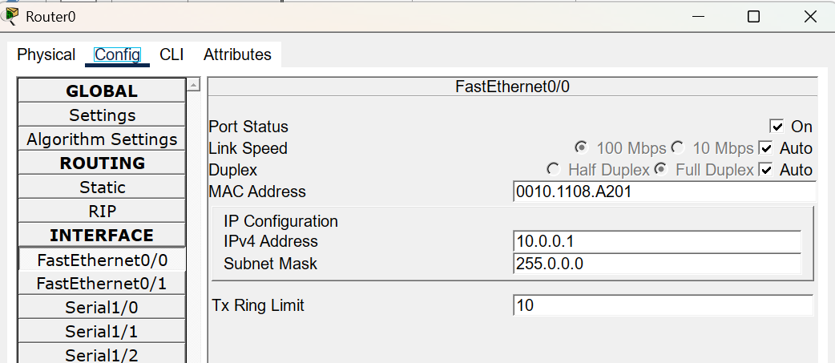

(Similarly configure for all routers)

Step 4: Enable RIPv1 on each Router:
Router# config t
Router(config)# router rip
Router(config-router)# version 1
Router(config-router)# network 192.168.1.0
Router(config-router)# network 0.0.0.0
Router(config-router)# exit
(Enable RIP v1 on all routers)

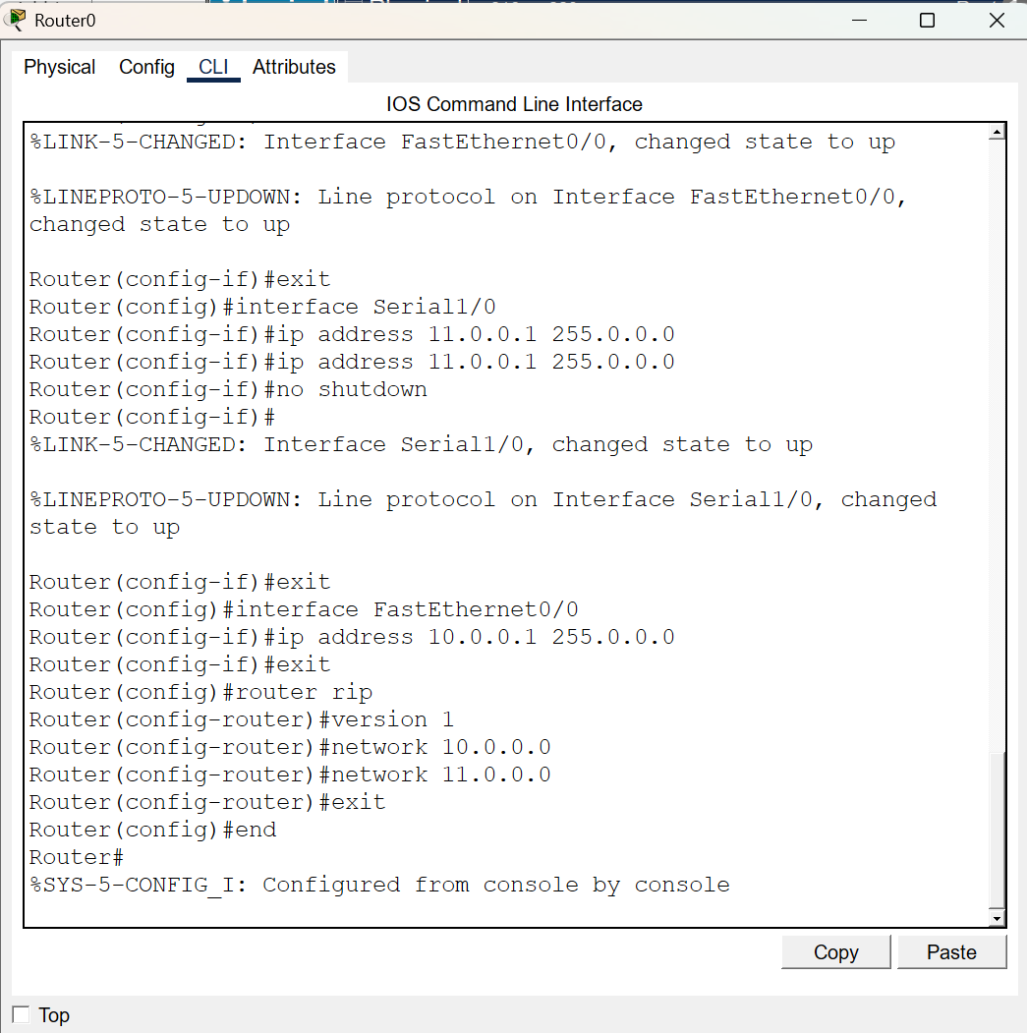

Step 5: Verify RIP Configuration:
On each router, check routing table:
Router# show ip route
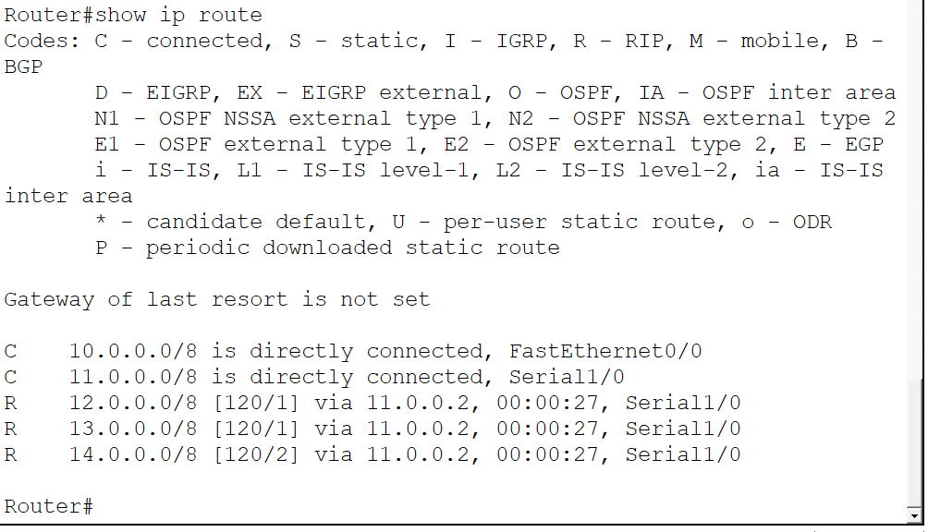
Ensure routes learned via RIP are visible with “R”.
Check RIP protocol details:
Router# show ip protocols
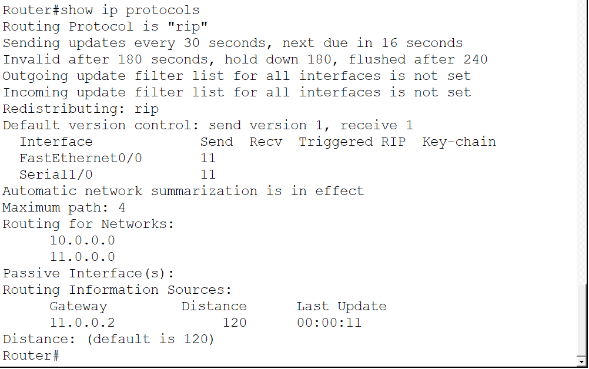

Step 6: Test Connectivity
- Open PC0 → Desktop → Command Prompt
- Ping PC4: ping 192.168.2.2
- Ping PC7: ping 192.168.3.2

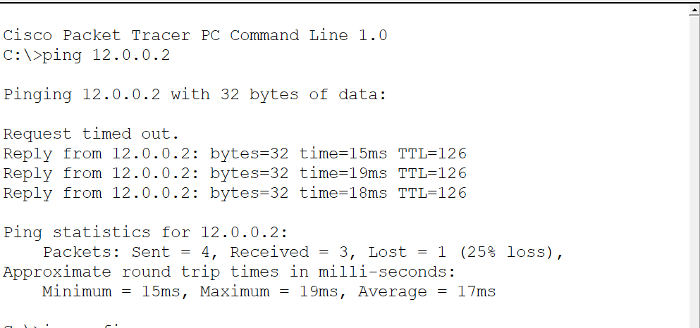

Practical 2
Objective: Configure routers to use the Routing Information Protocol (RIPv2) for dynamic routing. Enable RIP on the interfaces connected to different networks and verify that routes are being learned and propagated. Test the connectivity between hosts in different networks. Configure RIPv2 to advertise VLSM routes and verify them in the routing table. (Using Packet Tracer).

Theory:
RIP Version 2 (RIPv2):
RIPv2 is an enhanced version of RIP used for dynamic routing in IP networks. It is a distance vector routing protocol that allows routers to automatically exchange routing information and update their routing tables without manual static routing. RIPv2 uses the Bellman-Ford algorithm to calculate the best path and selects routes based on the hop count metric.
- The route with the least hop count is selected as the best route.
- Maximum hop count allowed is 15.
- Hop count 16 indicates an unreachable destination network.
- Routing updates are sent periodically every 30 seconds.

Features of RIPv2
RIPv2 is a classless routing protocol, unlike RIPv1. It supports modern subnetting techniques and can handle complex network addressing.
Important features of RIPv2 include:
- RIPv2 supports CIDR (Classless Inter-Domain Routing).
- It supports VLSM (Variable Length Subnet Masking).
- It includes the subnet mask in routing updates.
- It supports discontiguous networks properly.
- It sends updates using multicast address 224.0.0.9 instead of broadcast.
- It provides better efficiency than RIPv1 due to reduced unnecessary traffic.
- It supports authentication for secure routing updates.
- It allows routers to advertise routes with different subnet masks within the same major network.

Procedure:

Step 1: Create the Network Topology
- Open Cisco Packet Tracer.
- Add 3 routers.
- Add PCs (3 PC in each network).
- Connect:
- PC to Router using Copper Straight-Through.
- Router to Router using Serial DCE cable (or crossover if using Fast Ethernet).
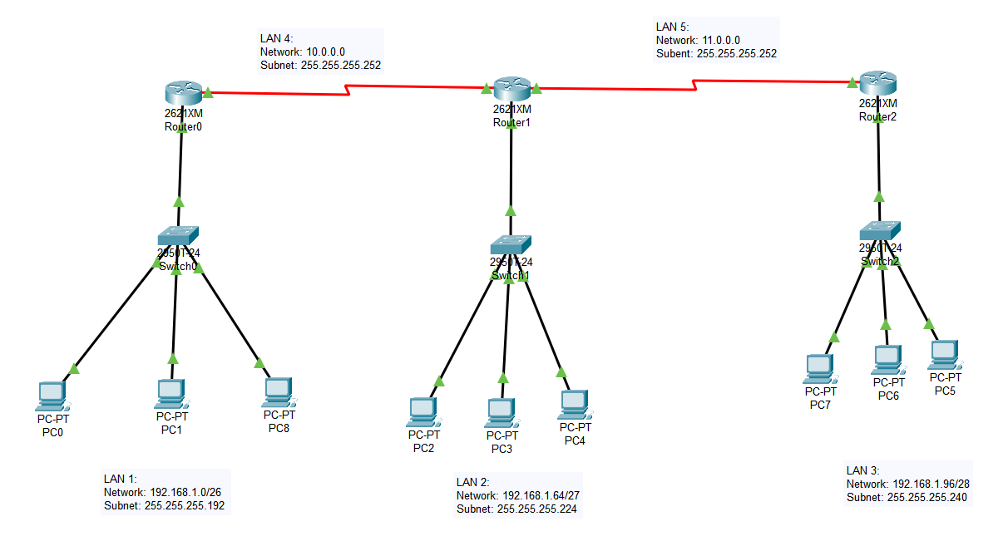
Step 2: Perform VLSM IP Addressing
Given network: 192.168.1.0/24, divided it into 3 subnets.
LAN subnets:
- LAN1: 192.168.1.0/26
- LAN2: 192.168.1.64/27
- LAN3: 192.168.1.96/28
Router-to-router links:
- R0-R1: 10.0.0.0/30
- R1-R2: 11.0.0.0/30

Step 3: Assign IP Address to PCs: for each PC
- Go to PC → Desktop → IP Configuration
- Assign:
  - IP Address
  - Subnet Mask
  - Default Gateway
- PC1: 192.168.1.2 / 255.255.255.192
- Gateway: 192.168.1.1
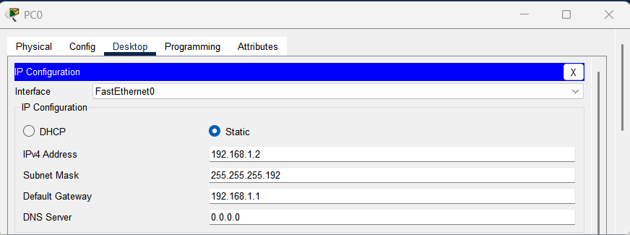
Step 3: Configure the Routers:
for each Router set up:
Router>enable
Router#
Router#configure terminal
Enter configuration commands, one per line. End with CNTL/Z.
Router(config)#interface FastEthernet0/0
Router(config-if)#ip address 192.168.1.1 255.255.255.192
Router(config-if)#ip address 192.168.1.1 255.255.255.192
Router(config-if)#
Router(config-if)#exit
Router(config)#interface Serial1/0
Router(config-if)#ip address 10.0.0.1 255.255.255.252
Router(config-if)#ip address 10.0.0.1 255.255.255.252
Router(config-if)#
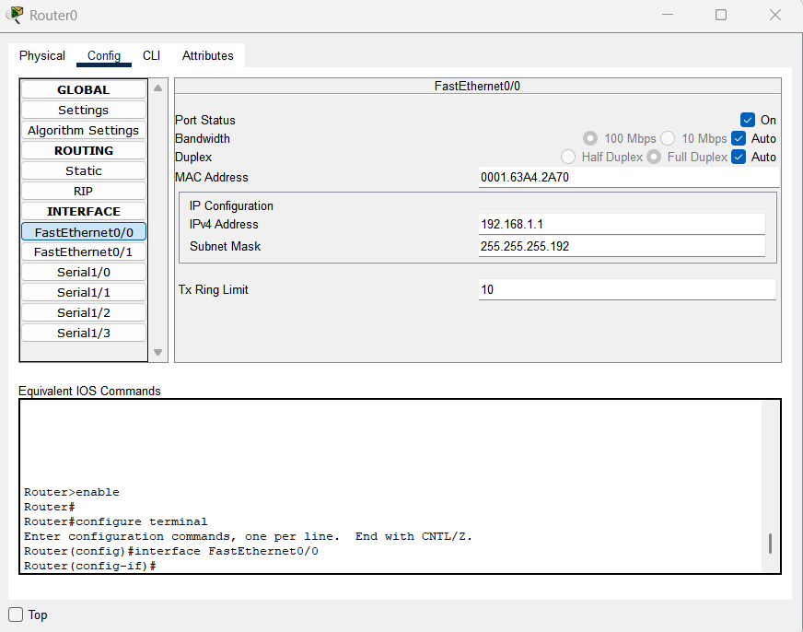

(Similarly configure for all routers)

Step 4: Enable RIPv2 on each Router:
Router# config t
Router(config)# router rip
Router(config-router)# version 2
Router(config-router)# network 192.168.1.0
Router(config-router)# network 0.0.0.0
Router(config-router)# exit
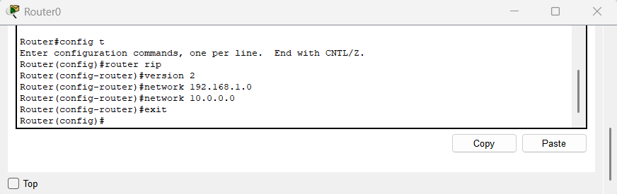
(Enable RIP v2 on all routers)
Step 5: Verify RIPv2 Configuration:
On each router, check routing table:
- Router# show ip route
RIP-learned routes are marked as:
- R 192.168.1.64/27
- R 192.168.1.96/28
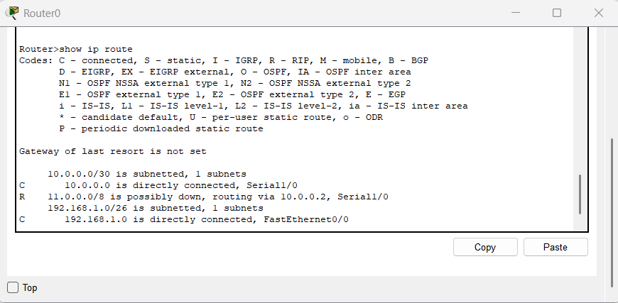
Check RIP protocol details:
- Router# show ip protocols

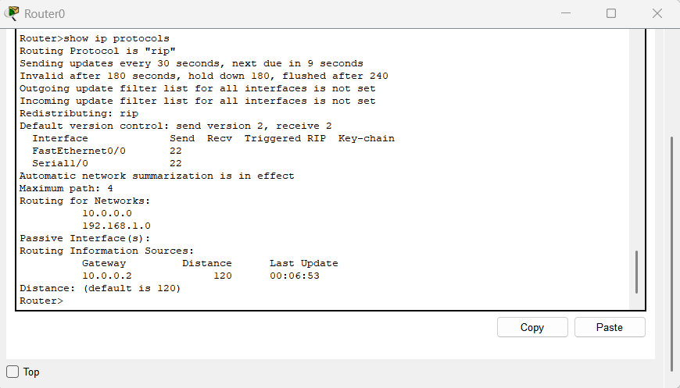

Step 6: Test Connectivity
- Open PC0 → Desktop → Command Prompt
- Ping PC4: ping 192.168.1.66
- Ping PC7: ping 192.168.1.98

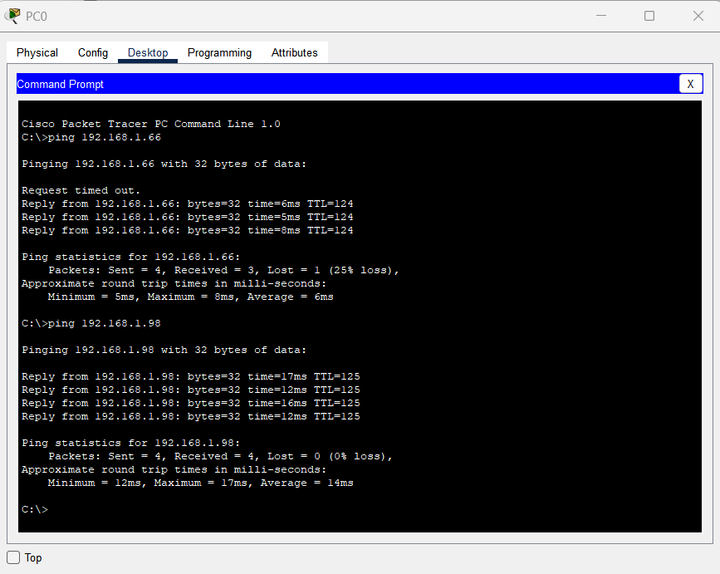

Practical 3
Objective: Configure routers to use the Open Shortest Path First (OSPF) protocol for dynamic routing. Enable OSPF on router interfaces in different networks and verify that routes are learned and exchanged correctly. Test connectivity between hosts in different networks. (Using Cisco Packet Tracer)
Theory:
Open Shortest Path First (OSPF):
OSPF is a link-state dynamic routing protocol used to exchange routing information between routers within an Autonomous System (AS). It uses the Dijkstra Shortest Path First (SPF) algorithm to calculate the shortest path to a destination network.
Unlike distance vector protocols, OSPF builds a complete map (topology) of the network and calculates the best route based on cost.
• OSPF is a link-state routing protocol.
• It uses Cost as its routing metric (based on bandwidth).
• The route with the lowest cost is selected as the best route.
• OSPF supports VLSM (Variable Length Subnet Masking).
• It supports classless routing.
• It converges faster than RIP.
• OSPF sends updates only when there is a change in the network (not periodically like RIP).
• OSPF uses multicast address 224.0.0.5 and 224.0.0.6 for routing updates.
OSPF Areas:
OSPF divides networks into areas to improve efficiency and scalability.
• Area 0 is called the Backbone Area.
• All other areas must connect to Area 0.
• In small topologies, we usually use Area 0 only.
Important characteristics of OSPF include:
• It uses the SPF (Dijkstra) algorithm to calculate routes.
• It supports hierarchical network design using areas.
• It supports authentication.
• It sends incremental updates instead of full routing tables.
• It prevents routing loops by maintaining a full topology database.
• It converges faster than distance vector protocols like RIP.
Thus, OSPF provides efficient routing, fast convergence, and scalability, making it suitable for medium and large networks.

Procedure:
Step 1: Create the Network Topology
- Open Cisco Packet Tracer.
- Add 3 routers.
- Add PCs (3 PCs in each network).
- Connect:
• PC to Router using Copper Straight-Through cable.
• Router to Router using Serial DCE cable (or crossover if using Fast Ethernet).
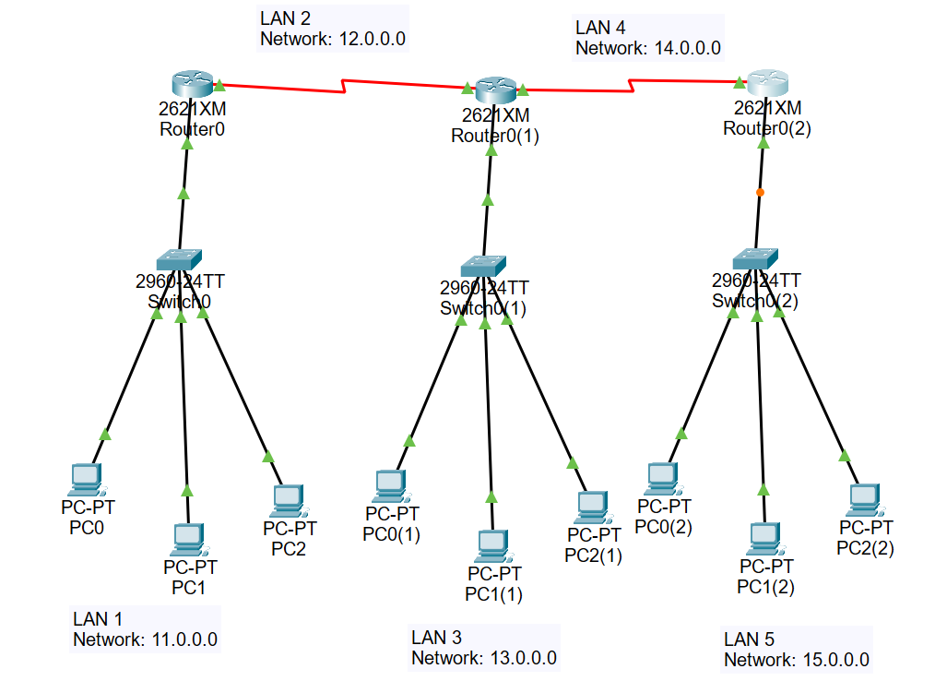
Step 2: Assign IP Address to PCs:
For each PC:
- Go to PC → Desktop → IP Configuration
- Assign:
IP Address
Subnet Mask
Default Gateway
Example:
• PC0: 11.0.0.2 / 255.0.0.0
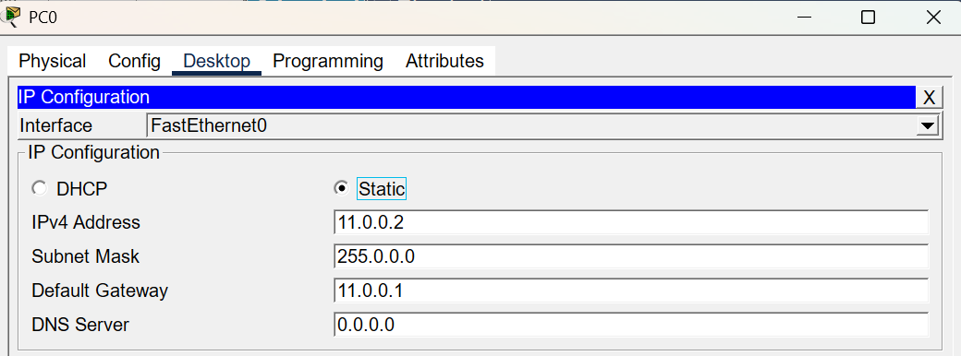
(Similarly assign IP addresses for PCs in other networks.)

Step 3: Configure the Routers:
For each router:
Router> enable
Router# configure terminal
Router(config)# interface FastEthernet0/0
Router(config-if)# ip address 11.0.0.1 255.0.0.0
Router(config-if)# no shutdown
Router(config)# interface Serial1/0
Router(config-if)# ip address 12.0.0.1 255.0.0.0
Router(config-if)# clock rate 64000
Router(config-if)# no shutdown
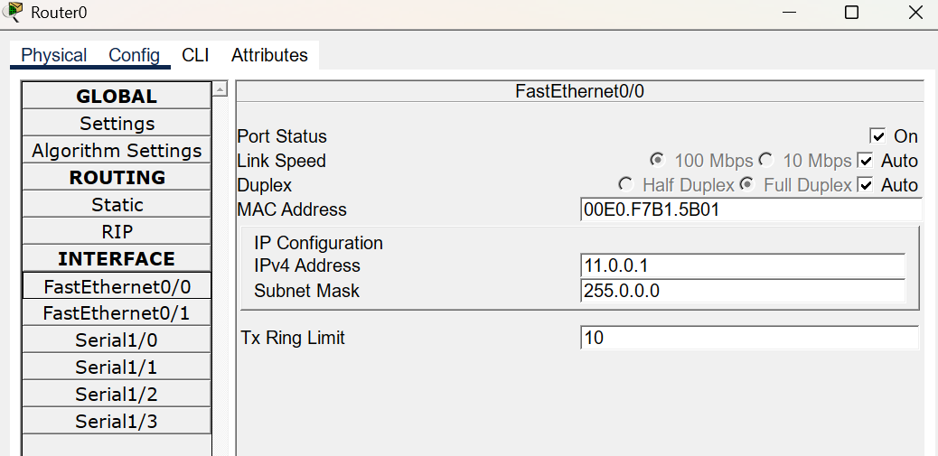
(Similarly configure all routers with appropriate IP addresses.)

Step 4: Enable OSPF on each Router:
Router# configure terminal
Router(config)# router ospf 1
Router(config-router)# network 11.0.0.0 0.255.255.255 area 1
Router(config-router)# network 12.0.0.0 0.0.0.255 area 1
Router(config-router)# exit
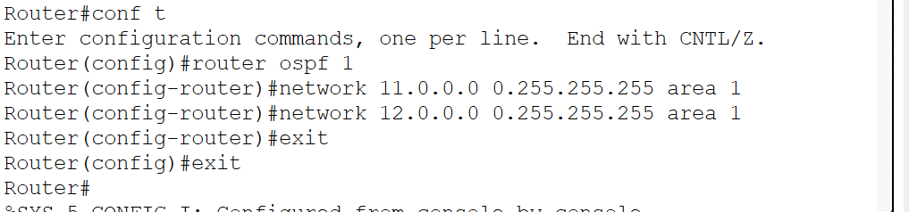
(Enable OSPF on all routers with their respective networks.)

Step 5: Verify OSPF Configuration:
Check routing table:
Router# show ip route
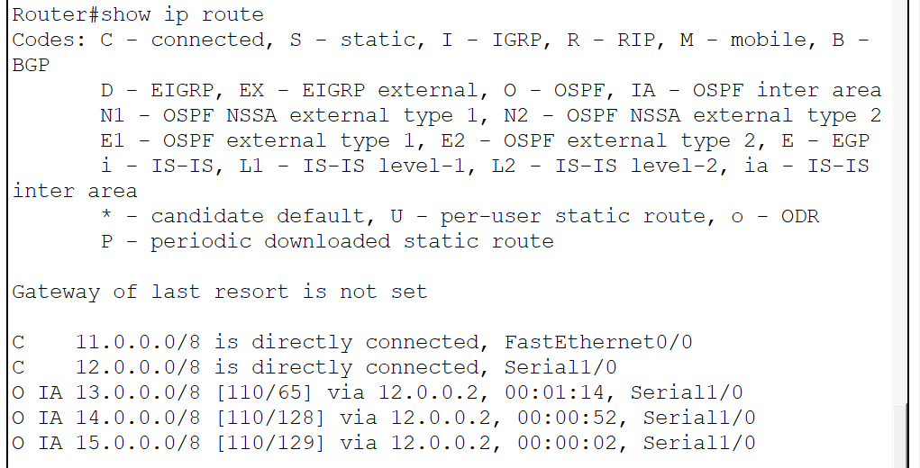
Routes learned via OSPF will appear with “O”.
Check OSPF neighbor relationships:
Router# show ip ospf neighbor
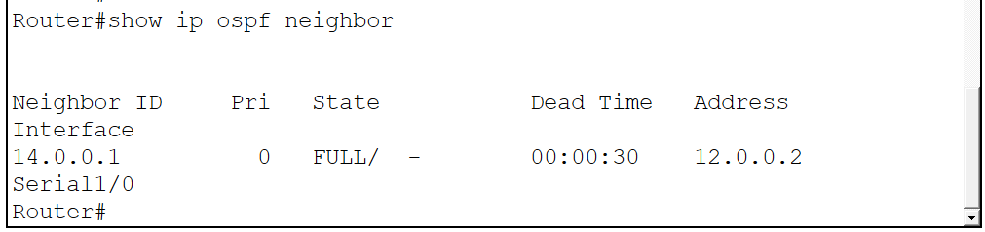
Check OSPF protocol details:
Router# show ip protocols
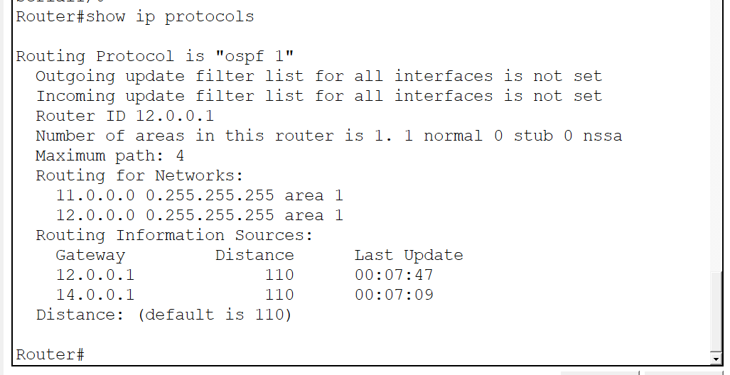
Step 6: Test Connectivity
- Open PC0 → Desktop → Command Prompt
- Ping PC1(2):
ping 15.0.0.3
- Ping PC0(1):
ping 13.0.0.2
- 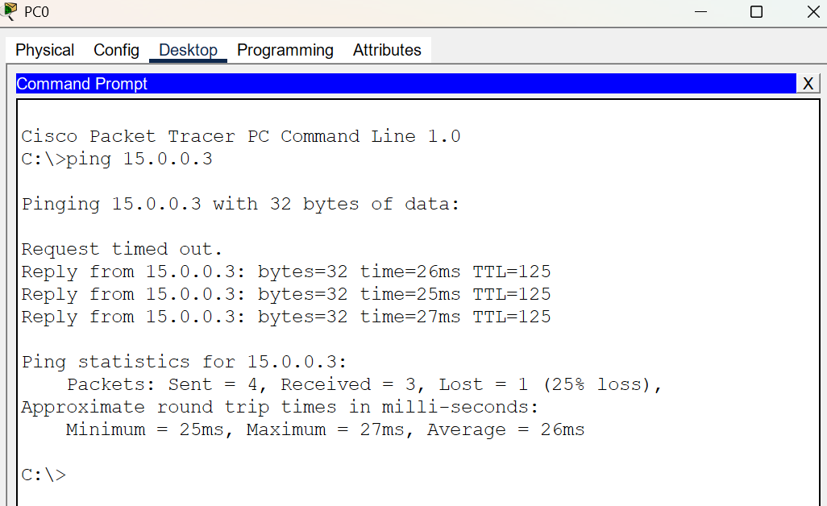
If OSPF is configured correctly, all pings should be successful.

Practical 4
Objective: Implement Dijsktra’s algorithm to compute the shortest path through a network.
Code:
#include<bits/stdc++.h>
using namespace std;
vector<int> dijkstra(int V, vector<vector<int>> adj[], int S) {
priority_queue<pair<int,int>,
vector<pair<int,int>>,
greater<pair<int,int>>> pq;

vector<int> dist(V, INT_MAX);
dist[S] = 0;
pq.push({0, S});

while (!pq.empty()) {
int node = pq.top().second;
int d = pq.top().first;
pq.pop();
if (d > dist[node]) continue;
for (auto &it : adj[node]) {
int adjNode = it[0];
int wt = it[1];

if (dist[node] + wt < dist[adjNode]) {
dist[adjNode] = dist[node] + wt;
pq.push({dist[adjNode], adjNode});
}
}
}
return dist;
}
int main() {
int V, E;
cin >> V >> E;
vector<vector<int>> adj[V];
for (int i = 0; i < E; i++) {
int u, v, w;
cin >> u >> v >> w;

adj[u].push_back({v, w});
adj[v].push_back({u, w});
}
int S;
cin >> S;
vector<int> result = dijkstra(V, adj, S);
cout << "Shortest distances from source " << S << ":\n";
for (int i = 0; i < V; i++) {
cout << "Node " << i << " -> " << result[i] << endl;
}
return 0;}

OUTPUT:
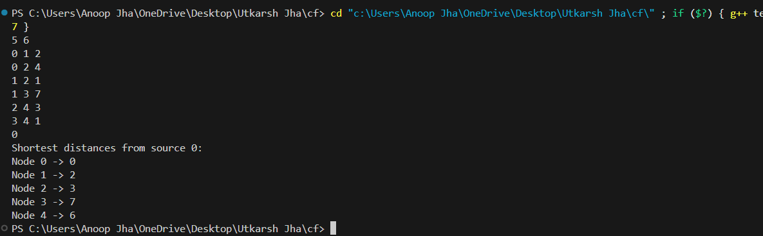

Practical 5;
Objective : Implement distance vector routing algorithm for obtaining routing tables at each node.
Code:
#include <bits/stdc++.h>
using namespace std;

#define INF 999
void bellmanFord(vector<vector<int>>& graph, int V, int src) {
vector<int> dist(V, INF);
vector<int> parent(V, -1);
dist[src] = 0;
for (int k = 1; k <= V - 1; k++) {
for (int u = 0; u < V; u++) {
for (int v = 0; v < V; v++) {
if (graph[u][v] != INF && dist[u] != INF) {
if (dist[u] + graph[u][v] < dist[v]) {
dist[v] = dist[u] + graph[u][v];
parent[v] = u;
}
}
}
}
}

cout << "\nRouting table for Router " << src << ":\n";
cout << "Destination\tNext Hop\tCost\n";

for (int dest = 0; dest < V; dest++) {

if (dest == src) continue;

if (dist[dest] == INF) {
cout << dest << "\t\t-\t\tINF\n";
continue;
}
int nextHop = dest;
while (parent[nextHop] != src) {
nextHop = parent[nextHop];
}
cout << dest << "\t\t" << nextHop << "\t\t" << dist[dest] << endl;
}
}
int main() {
int V;
cin >> V
vector<vector<int>> graph(V, vector<int>(V));
for (int i = 0; i < V; i++)
for (int j = 0; j < V; j++)
cin >> graph[i][j];
for (int i = 0; i < V; i++) {
bellmanFord(graph, V, i);
}
return 0;
}

OUTPUT:
